Ridge Regression

Part 1 Geometric Intuition and Code

Regularized Linear Models

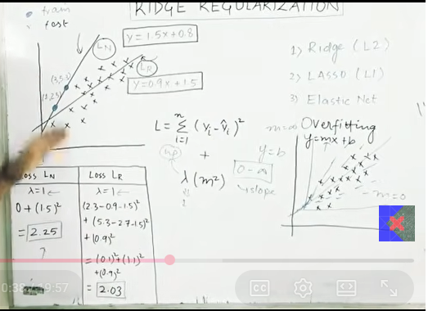

Regularization

Definition
Regularization is a technique used in Machine Learning to reduce overfitting by adding a penalty term to the loss (cost) function.
It helps the model generalize better on unseen (test) data.

Why do we need Regularization?
A machine learning model may perform:
- Very well on training data
- Poorly on test data
This problem is called Overfitting.
Regularization reduces the complexity of the model and prevents overfitting.

What is Overfitting?
Overfitting occurs when the model learns:
- Actual patterns
- Noise present in the training data
As a result:
- High Training Accuracy ✅
- Low Testing Accuracy ❌

Idea of Regularization
Normally, Linear Regression minimizes the Cost Function:
[
J(\theta)=\sum (y-\hat{y})^2
]
Regularization adds a penalty term.
New Cost Function:
[
J(\theta)=\sum (y-\hat{y})^2+\lambda \times \text{Penalty}
]
where
- ( \lambda ) = Regularization parameter (Alpha)
- Penalty depends on the type of regularization.

Types of Regularization
There are mainly three types:
- Ridge Regression (L2)
- Lasso Regression (L1)
- Elastic Net (Combination of L1 and L2)

1. Ridge Regression (L2 Regularization)

Formula
[
J(\theta)=RSS+\lambda \sum \beta_i^2
]
Penalty Term:
[
\lambda(\beta_1^2+\beta_2^2+\cdots+\beta_n^2)
]

Characteristics
- Shrinks coefficient values
- Coefficients become small but never exactly zero
- Uses all features
- Reduces model complexity
- Works well when many features contribute

2. Lasso Regression (L1 Regularization)

Formula
[
J(\theta)=RSS+\lambda \sum |\beta_i|
]
Penalty Term:
[
\lambda(|\beta_1|+|\beta_2|+\cdots+|\beta_n|)
]

Characteristics
- Some coefficients become exactly zero
- Performs Feature Selection automatically
- Removes unimportant features
- Produces a simpler model

3. Elastic Net
Elastic Net combines Ridge and Lasso.

Formula
[
J(\theta)=RSS+\lambda_1\sum |\beta|+\lambda_2\sum \beta^2
]

Characteristics
- Combines feature selection and coefficient shrinking
- Useful when many correlated features exist

Hyperparameter Alpha (λ)
Alpha controls the amount of regularization.

Small Alpha
- Weak Regularization
- Complex Model
- May Overfit

Large Alpha
- Strong Regularization
- Very Simple Model
- May Underfit

Best Alpha
Choose Alpha using:
- Cross Validation
- Grid Search

Effect of Alpha
Alpha Value | Model
0 | Same as Linear Regression
Small | Slight Regularization
Medium | Best Generalization
Large | Underfitting

Ridge vs Linear Regression
Linear Regression
- Can overfit
- Larger coefficients
- More complex model
Ridge Regression
- Smaller coefficients
- Better generalization
- Less overfitting

Ridge vs Lasso
Ridge | Lasso
L2 Regularization | L1 Regularization
Squares coefficients | Absolute coefficients
Coefficients become small | Some coefficients become zero
No Feature Selection | Automatic Feature Selection
Uses all features | Removes unnecessary features

Elastic Net
Advantages
- Combines Ridge and Lasso
- Handles correlated features well
- Performs feature selection
- Prevents overfitting

Advantages of Regularization
- Reduces Overfitting
- Improves Generalization
- Makes model more stable
- Prevents very large coefficients
- Works well on high-dimensional data

Disadvantages
- Need to tune Alpha
- Large Alpha may Underfit
- Slight increase in computation

Important Interview Questions

Q1. What is Regularization?
Regularization is a technique used to reduce overfitting by adding a penalty term to the cost function.

Q2. Why is Regularization used?
To reduce model complexity and improve performance on unseen data.

Q3. What is Ridge Regression?
Ridge Regression uses L2 Regularization by adding the squared coefficients as a penalty.

Q4. What is Lasso Regression?
Lasso Regression uses L1 Regularization by adding the absolute values of coefficients and can perform feature selection.

Q5. What is Elastic Net?
Elastic Net combines both L1 and L2 regularization.

Q6. What happens if Alpha is very large?
The model becomes too simple and may underfit.

Q7. What happens if Alpha is zero?
The model becomes ordinary Linear Regression with no regularization.

One-Line Revision
- Regularization → Reduces Overfitting
- Ridge → L2 → Squares of coefficients
- Lasso → L1 → Absolute values of coefficients
- Elastic Net → L1 + L2
- Alpha (λ) controls regularization strength
- Small Alpha → Overfitting risk
- Large Alpha → Underfitting risk
- Ridge keeps all features; Lasso can remove features (coefficients become zero)

